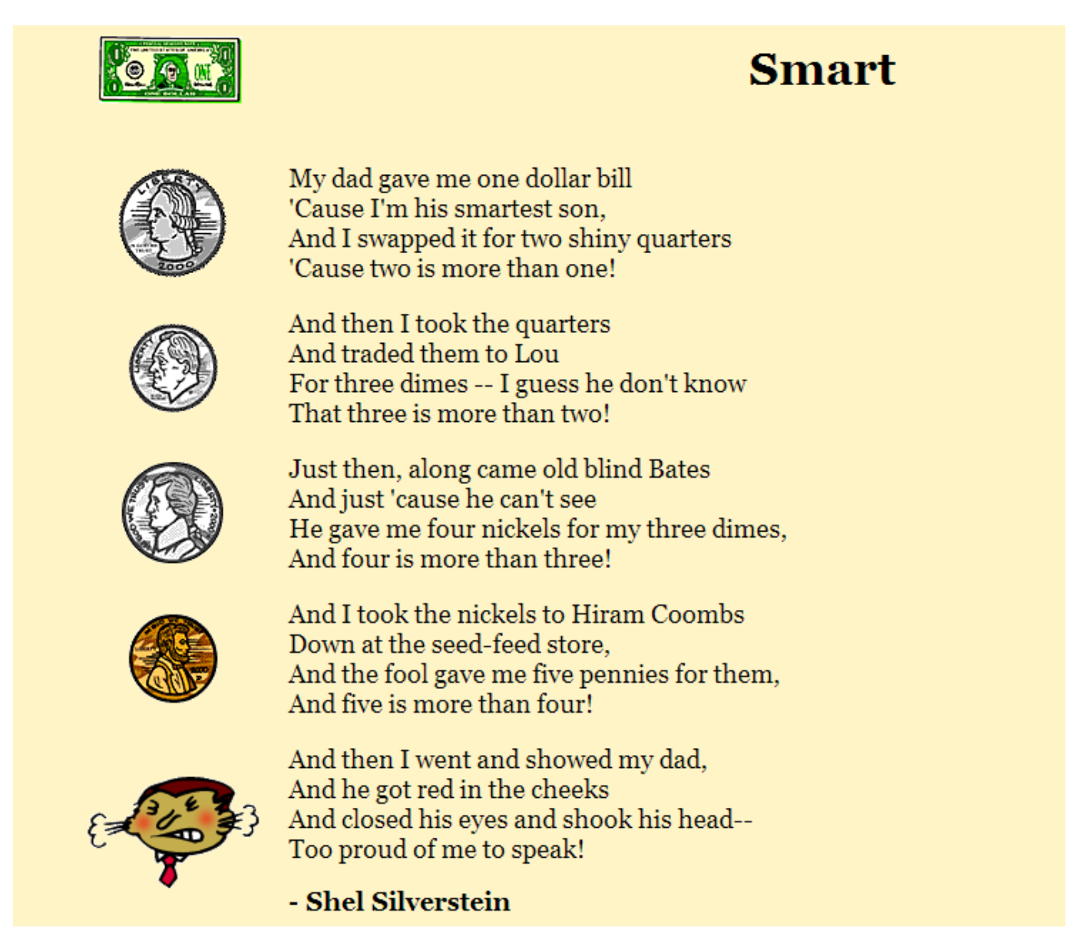

How is the poem ironic? Include one example from the poem and explain the irony.

