HYGIENE
FROM THE FEBRUARY 2015 ISSUE

Grossbusters! Hygiene Help Is On The Way

Jamie

Primeau

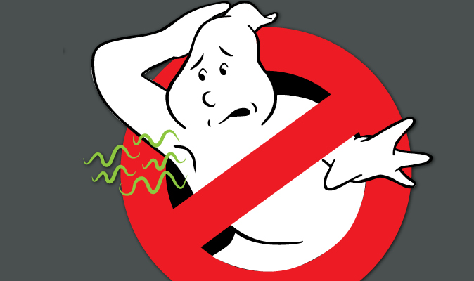
From sweaty pits to flaky scalps, we asked doctors about how to solve your biggest hygiene dilemmas.

Illustration by Marybeth Butler
Sometimes it can feel like your body is being haunted by a pimply, greasy, stinky spirit. But don’t worry—help is on the way.
Exhausted after a long week at school, you plop down on the couch, excited for a popcorn-fueled, Friday-night movie marathon. You unlace your sneakers, slide off your shoes—and then it hits hard, like a sack of stale cheese puffs.
Wait, is that you? Are you the Kid With Stinky Feet?
It makes you never want to remove your shoes again. But you can’t keep your feet covered forever.
First, let’s clear the air—literally and figuratively. The hormones your body produces during puberty can trigger changes in the way your body behaves. Your sweat and oil glands go into overdrive, and your hair, skin, and smell may show it. “Even though these changes may be frustrating or seem gross, they’re totally normal,” says Dr. Stephanie Crewe, an adolescent medicine specialist. “It’s just a part of growing up and becoming a young adult.”
All it takes is good hygiene and clean socks to defeat those foul-smelling feet, and the solutions to some of your other body concerns are just as simple. We asked experts to share their best tips. From sweaty pits to flaky scalps, we’ve got you covered.

I can’t stop sweating, and as the day goes on, I start to smell too. Help!
—B.O. Verit, 16
Get this: Sweat itself is odorless. Body odor is actually caused by bacteria that live on your skin and multiply in the damp, dark environment of your sweaty armpit. These bacteria then break down the sweat into amino acids, and that process is what results in the funk.
We’re not telling you this to gross you out; we want you to understand why getting rid of BO starts in the shower. Washing yourself with soap daily—taking care to gently scrub inside each and every crevice—will wipe away the bacteria that may make your sweat stink.
And here’s the bonus: Once you’re squeaky clean, your deodorant will keep you smelling that way, says Dr. Crewe. Use one with an antiperspirant (this combo covers the smell and decreases sweating) every morning, then stash it in your bag to re-up when you’re active—whether it’s in gym or at marching-band practice.
P.S. If you’re dripping through your shirt even when you’re not exercising, you could have a rare but totally treatable problem called hyperhidrosis—aka excessive sweating. Tell your doctor, who may prescribe a more powerful deodorant.

Anytime I go to change into my sneakers in gym class, my feet reek! How can I get rid of this horrible odor for good?
—Stan Keefeet, 14
Believe it or not, your feet contain more than 250,000 sweat glands that produce a pint of sweat every day—more per square inch than any other body part! Add shoes (the ultimate dark-and-damp, bacteria-breeding environment), and you’ve got the equation for serious stank.
To keep the odor to a minimum, wash your feet with soap and water twice a day, taking special care to get those shadowy, bacteria-breeding areas. “I tell kids with really smelly feet to take a toothbrush (not the one you use to brush your teeth), put soap on it, and scrub between their toes,” says Dr. Dyan Hes, medical director at Gramercy Pediatrics.
Then dry your feet completely and put on clean socks. (If you go sock-less, your shoes’ insoles will soak up odor and bacteria like a sponge, says Dr. Crewe.) Alternating shoes every other day may help too. Give each pair a day to air out, sprinkling the insoles with baby powder to help absorb moisture and odor.

No matter how much I wash my hair, I get little white flakes on my head and shoulders. Why? And how can I get rid of them?
—Dan Druff, 15
That sounds like dandruff. Some people have it, others don’t. It’s pretty much the luck of the draw. Doctors don’t know why this condition develops, but they do know that it causes your scalp’s skin cells to get inflamed and scaly, then shed rapidly— resulting in those flakes you’ve been flicking off your sweater.
Unfortunately, dandruff can’t be cured, but you can keep it under control. Try using a dandruff shampoo containing selenium sulfide or zinc—these ingredients help keep the scalp healthy and oiled.

I break out all over my back. It’s especially awkward when I’m getting changed for softball practice—what can I do?
—Becky Bacne, 17
Did you know the skin on your back is thicker than on your face? It also has larger pores and more oil glands. That’s why some people have crystal-clear complexions but acne attacks all over their backs.
The good news is, acne washes aren’t only for your face—you can use them on your back too. In the shower, apply one containing benzoyl peroxide to a scrub brush and scrub. This will clear out your pores and slough off dead skin cells. A salicylic acid astringent, which you can find at a drugstore, might help clear your skin too. Dab it on a cotton ball, then gently rub it over your back to remove excess sweat and bacteria. (If none of this works, ask your parents to make an appointment with your doctor, who might prescribe a stronger treatment.)

Special thanks to our experts: Dr. Dyan Hes, Medical Director atGramercy Pediatrics, and Dr. Stephanie Crewe, Assistant Professor, Division of Adolescent Medicine at the Children's Hospital of Richmond at Virginia Commonwealth University.

