ACTIVISM
FROM THE FEBRUARY 2016 ISSUE

The Autism Activist

Sandy M.

Fernández

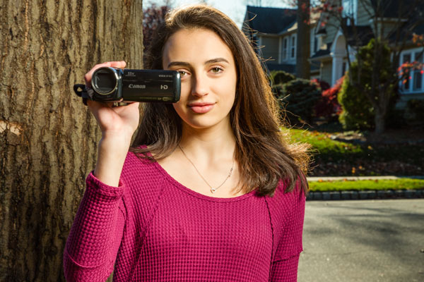
Alex's tip: “Don’t just post your message and let it sit there. Get the word out! After my film was done, I sent links to everyone I thought would be interested. Then it blew up!”

Matt Furman

With a single YouTube video, Alex, 16, has helped thousands of teens understand a complex disorder.
One day at summer camp, Alex Jackman joined a girl in a wheelchair who usually ate lunch alone—just out of curiosity. “I learned her name was Jaime and that she had cerebral palsy,” says Alex, now 16. “We became good friends.”
But Alex was haunted by how close she came to never meeting her friend at all. Too many kids don’t understand special needs, Alex realized—from physical disabilities to learning difficulties—so they don’t look past those differences to get to know the person. “I almost didn’t,” she says, “and I would’ve missed out.”
Alex decided to better those odds. Inspired by her volunteer work with a local autism organization, she created a video about the developmental disorder, specifically targeted at teens. “I wanted to make something simple that put you in someone with autism’s shoes,” she explains.
Alex interviewed kids she’d met through her volunteer work, contacted experts, and spent a year writing, filming, and editing. She then posted the results on YouTube—and “A Teen’s Guide to Autism” took off.
Today, the video has been seen tens of thousands of times by people around the world and won dozens of awards. But what means the most to Alex are the messages she’s received from people living with autism who finally feel understood. “One mom wrote that while watching the film, her son said, ‘That’s me. That’s why I do that.’ It shows you’re never too young to make a difference.”

More autism activists
Connor Archer This Maine high school senior created an annual walk-run to benefit the early education programs that helped him with his autism-related issues. His efforts have netted more than $12,000!
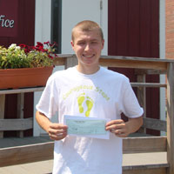

Marissa Hacker Inspired by her twin brother who has autism, Marissa founded a social group that brings kids with special needs together in friendship. She even throws them a yearly prom.

David and Daniel Militello In part by hosting concerts, these teen brothers (both talented musicians on the autism spectrum) have collected $8,000 for music therapy for special-needs kids.
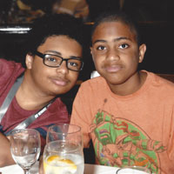

The Facts That Matter: Autism
• 1 out of 68 U.S. kids has an autism disorder
• 50% of those kids has average intelligence or above
• 46% of teens on the autism spectrum have been bullied
Sources: 1-2. Centers for Disease Control and Prevention, 3. Archives of Pediatrics & Adolescent Medicine

MORE FROM THIS ISSUE
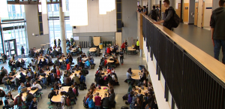
Choices Challenge: Mix It Up at Lunch
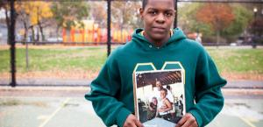
My Dad Is in Prison

