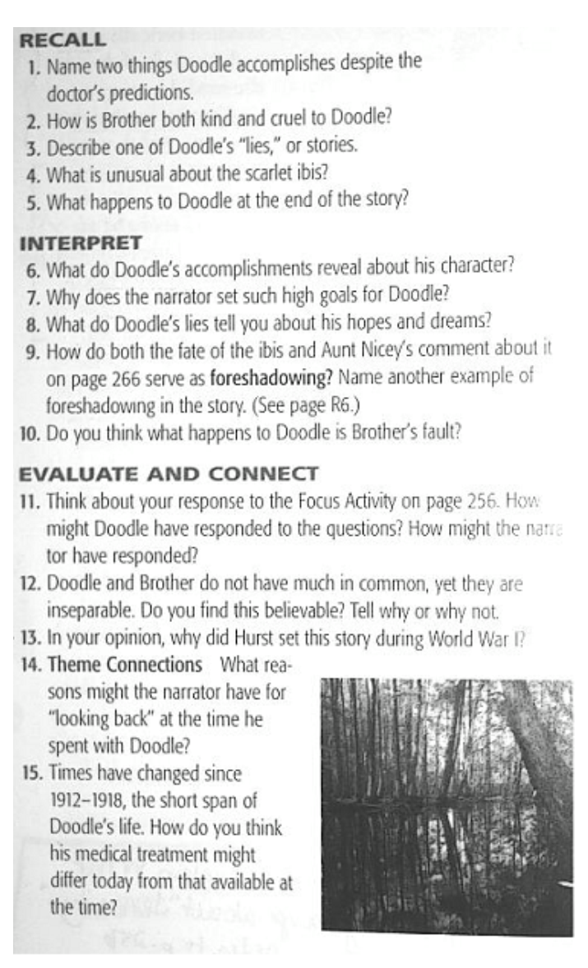

**“The Scarlet Ibis” Questions**

**Write your answers on your own paper. You must respond in complete sentences (min. of 9 words) and in blue/black ink.**