Examples of Literary Elements in the Odyssey
Identify each quote as an example of one literary element from the word bank. Each word may be used more than once.
Word bank: Epithet, Personification, Simile, Epic Simile, Repetition
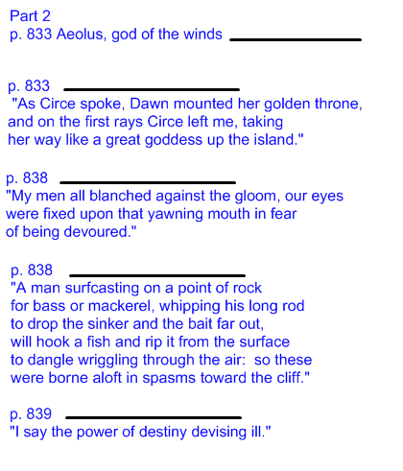
Type an element here
Type an element here
Type an element here
Type an element here
Type an element here
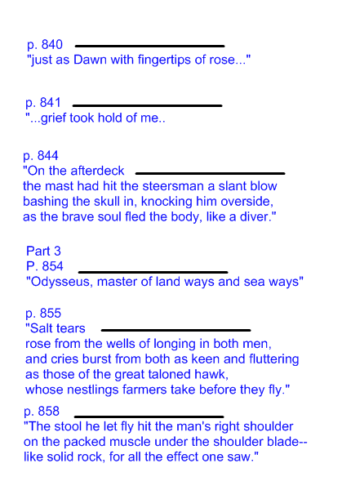
Type an element here
Type an element here
Type an element here
Type an element here
Type an element here
Type an element here

