Examples of a Cinquain and a Limerick
Note: Remember to look at your definition of these two types of poetry. The definitions can be found on the colored paper with the tree map for “Different Types of Poetry.”
CINQUAIN: Tips for writing a cinquain can be found on the Poetry page of the weebly.
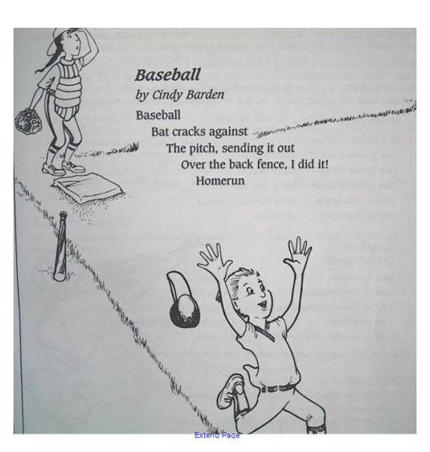

LIMERICK
