Comics: [Random](http://theoatmeal.com/random) [Most Popular](http://theoatmeal.com/tag/popular) [All](http://theoatmeal.com/comics) [Cats](http://theoatmeal.com/tag/cats) [Grammar](http://theoatmeal.com/tag/grammar) [Food](http://theoatmeal.com/tag/food) [Animals](http://theoatmeal.com/tag/animals) [Tech](http://theoatmeal.com/tag/tech)



Credit: http://theoatmeal.com/comics/apostrophe

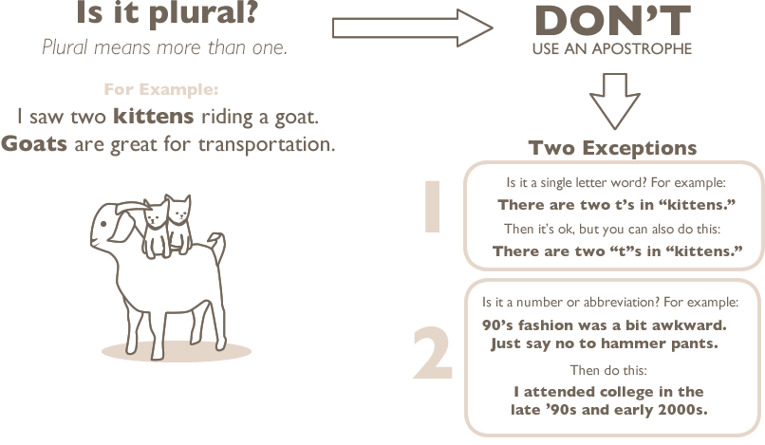

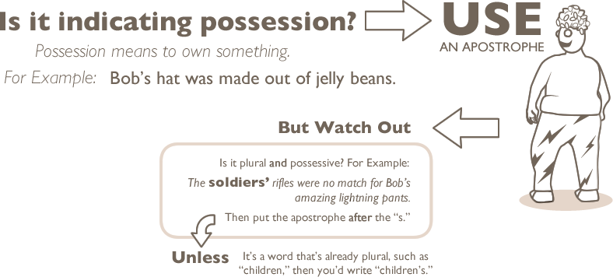

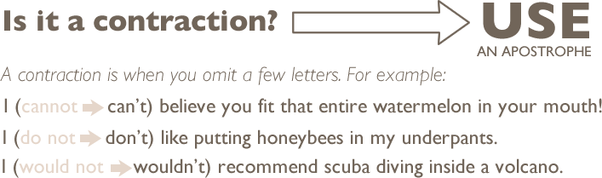

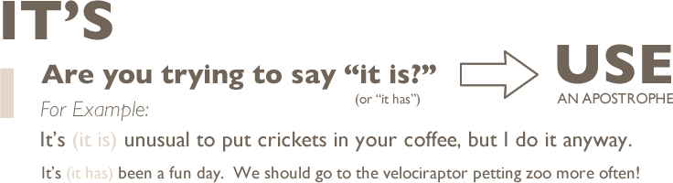

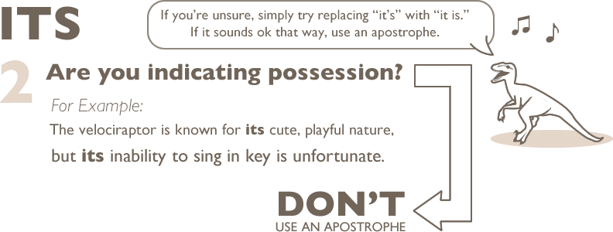

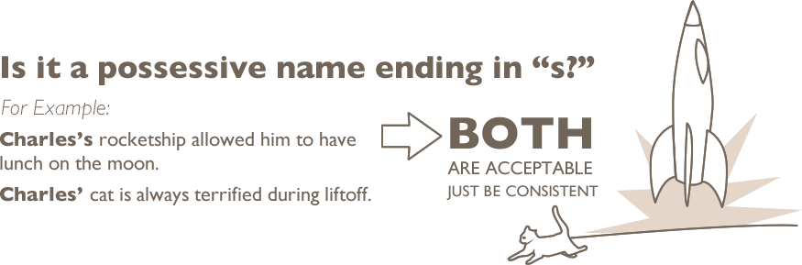



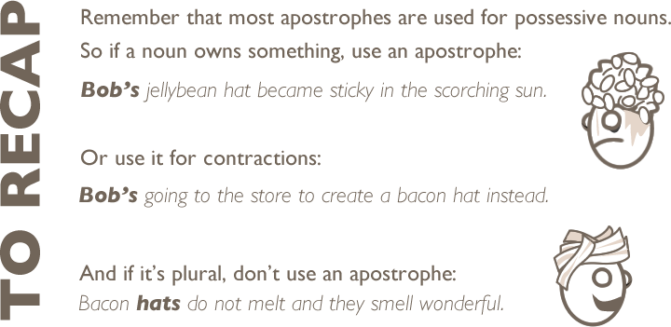

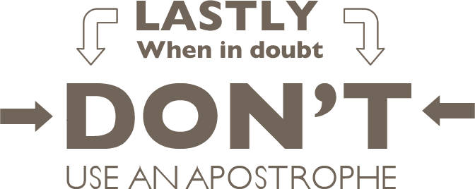

[](http://shop.theoatmeal.com/products/how-to-use-an-apostrophe)