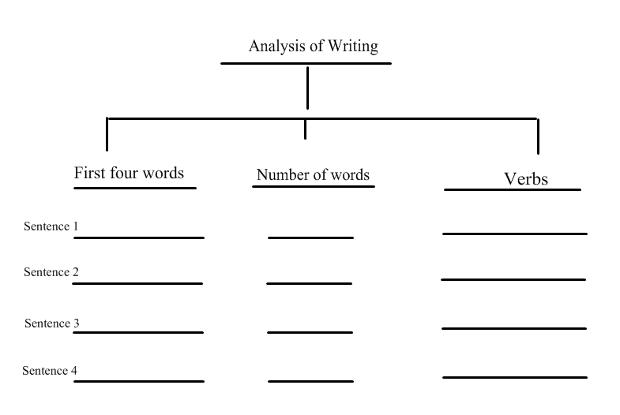

Copy all the verbs that appear in each sentence.

Copy the first four words in each sentence.

Count how many words you have in each sentence.